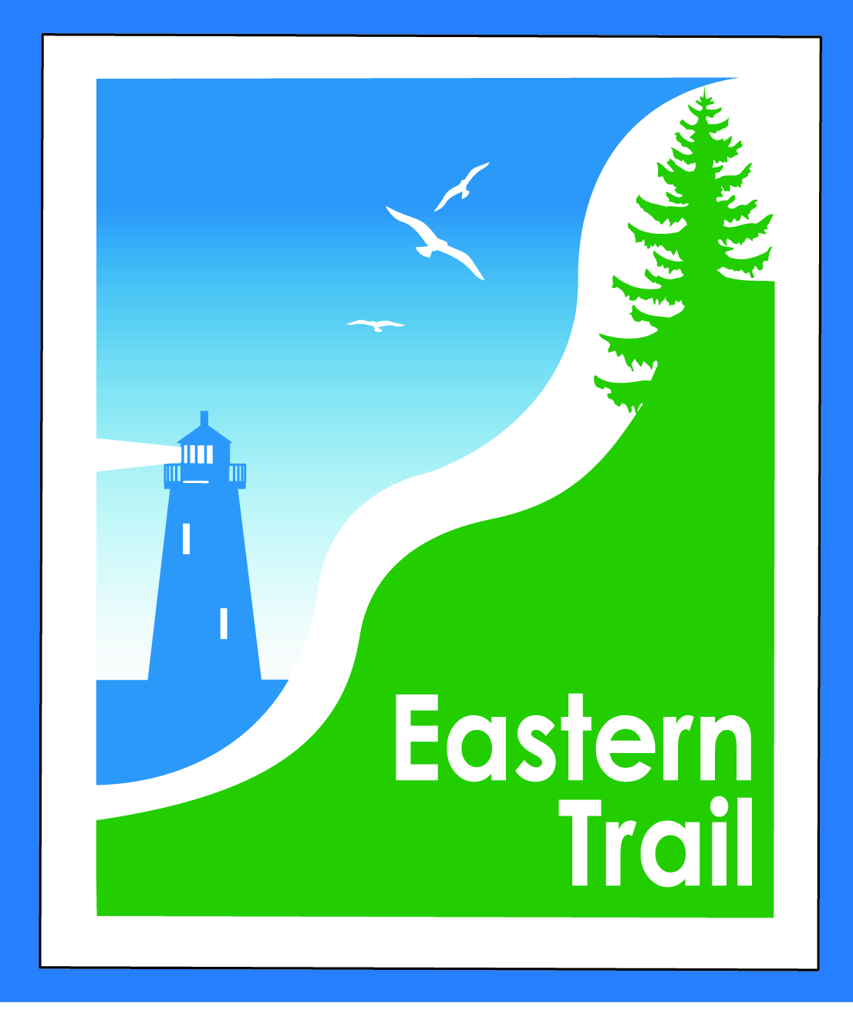

ETMD Board of Directors – Minutes – DRAFT BY CB
Kennebunk Town Hall - Third Floor Conference Rm – February 10, 2016 - 8:30 – 10:30 a.m.

Attendees: Marianne Goodine, Val Camire, Bob Hamblen, Tom McCullum, Eric Labelle, Greg Tansley, Joe Yuhas,
Jim Bucar, Carole Brush
President Goodine called the meeting to order at 8:37 AM.
- Minutes of January 13, 2016 – included – needs vote –
  - Motion by BH, Second by JY Approved by all.

- Financial Priorities – 10 min
- Review of current financial report – Val/Carole – included – needs vote
  - Motion by BH, Second by JB Approved by all.
- Events – 2016 status – Carole
  - CB reports $ and participation down from last year. Anticipate $1000 in income. One OOB event dropped out. CB to review with OOB personnel.
- Dues status – Marianne/Carole
  - Scarborough dues received
  - Request to attend Town Meeting for S Berwick & Wells
    - CB reported both meetings went well. S Berwick approved dues, Wells Budget committee approved – needs to go before council for vote.
  - Report on conversation w/N Berwick & next steps
    - Respond to Town Manager questions
      - CB spoke with Town Mgr. Morin - they would lie a trail but do not have $, also have concern over proximity to sanitary district
    - Outreach to Pratt & Whitney, Hussey Seating
      - CB has email and phone calls in to P&W, needs new contact – prior one left company. CB requesting to attend H&W fair in August, meet with P&W in March to give update on trail status.

- ETMD Priorities - 100 min
  - Updates & next steps re Kennebunk – South Berwick CLA – Carole
    - CB sent comments back to Unitil, waiting for response
  - Review and comments on Unitil proposed amendment to Section 5 – current CLA’s – All
    - After lengthy discussion, it was determined a side-by-side comparison is needed of Unitil’s first draft and their second official draft. CB to create and pass on to all by 2/15.
  - Reports from Executive Director and Municipalities (includes new projects, existing trail conditions, maintenance concerns)
    - Scarborough project proceeding well, route approved, funding strategy meetings on going
    - (CB needs input from GT re his notes on balance of reports – will send to all as addendum and vote on in April)
  - Future ET planning – Carole – 3 min
    - Status office and storage space – Saco has storage, still looking for alternate location
    - Status on marketing materials, outreach efforts and funding sources
        - Seeking response from municipalities re additional directional trail signage
BH received input form all but Arundel, CB to follow up with Arundel so we can place order.
CB reported ETA purchased new marketing materials to show poster and banner of trail with current and proposed off road proposed routes. JB revised the ET slide show to include before and after signs and segments from the Economic Development Study. Slide show available to all towns to add to website if desired.
- Other Business - 2 min – issues? Concerns

- Next Meeting – March 9, 2016

- Adjourn Motion to adjourn at 10:27 AM by VC, second by EL, Approved by all

Respectfully submitted,
Carole Brush, Executive Director

