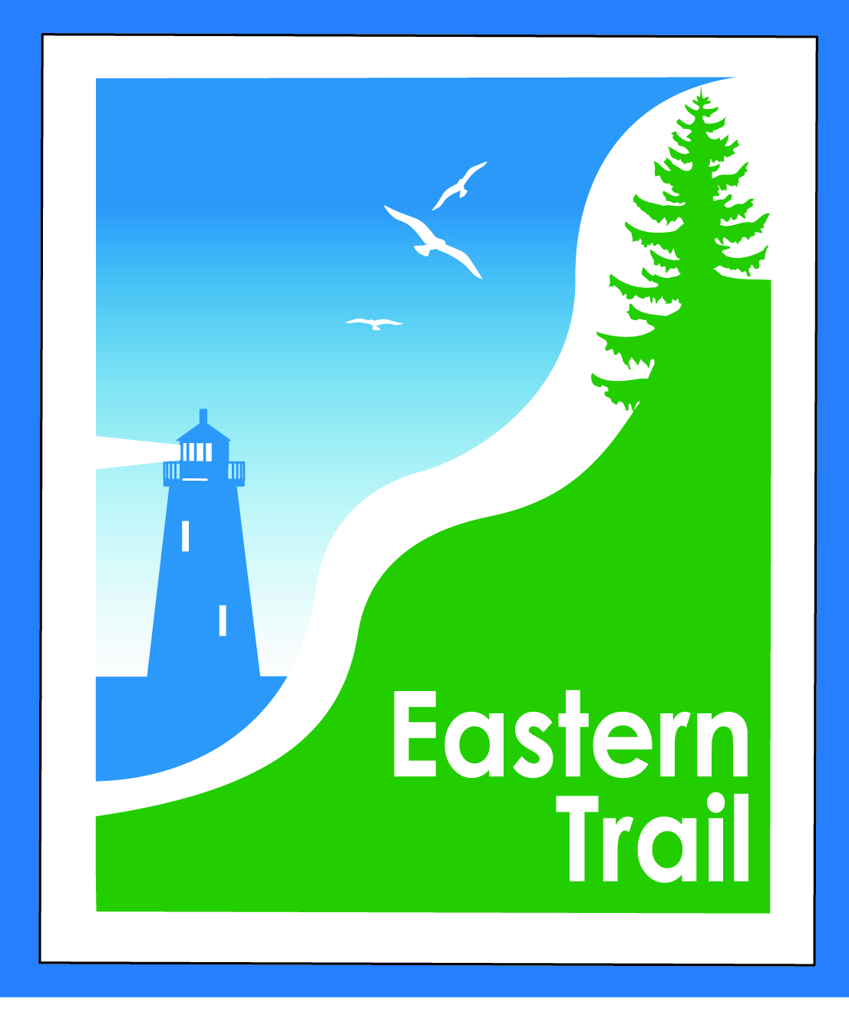

ETMD Board of Directors Agenda
Kennebunk Town Hall - Third Floor Conference Rm – February 14, 2018 - 8:30 – 10:30 a.m.

- Welcome & Introductions – 5 min
- Arundel Conservation Trust Presentation – Leia Lowery, Linda Zuke – 20 minutes
- Southern Maine Planning & Development Presentation – Paul Schumacher – 20 minutes
- Minutes of January 10, 2018 (to follow) needs vote - 3 min

- Financial – 5 min
  - January report (to follow)- needs vote – Carole, Val
  - Dues Status - All
- Operations – 25 min
  - Review / discuss current and future Event Policy – Bill, Carole
  - Review / discuss Trade Mark status and future policy – Bill, Bob H
  - Update – Arundel-Kennebunkport Cottage Preserve - Carole
- Ongoing / Proposed Projects - 25 min
  - Close the Gap - Scarborough – 019386.00 – Bill, Carole
  - Blazing the Trail South - Kennebunk – South Berwick – Marianne, Eric, Carole
  - Over the River – Saco-Biddeford connection – Greg, Bob H, Crole
  - Reports from Municipalities

- Outreach & Events – 15 min
  - EIS - Jim
  - Upcoming ETA / ETMD events - Carole

- Other Business? – 2 min

- Next Meeting – March 14, 2018

- Adjourn

