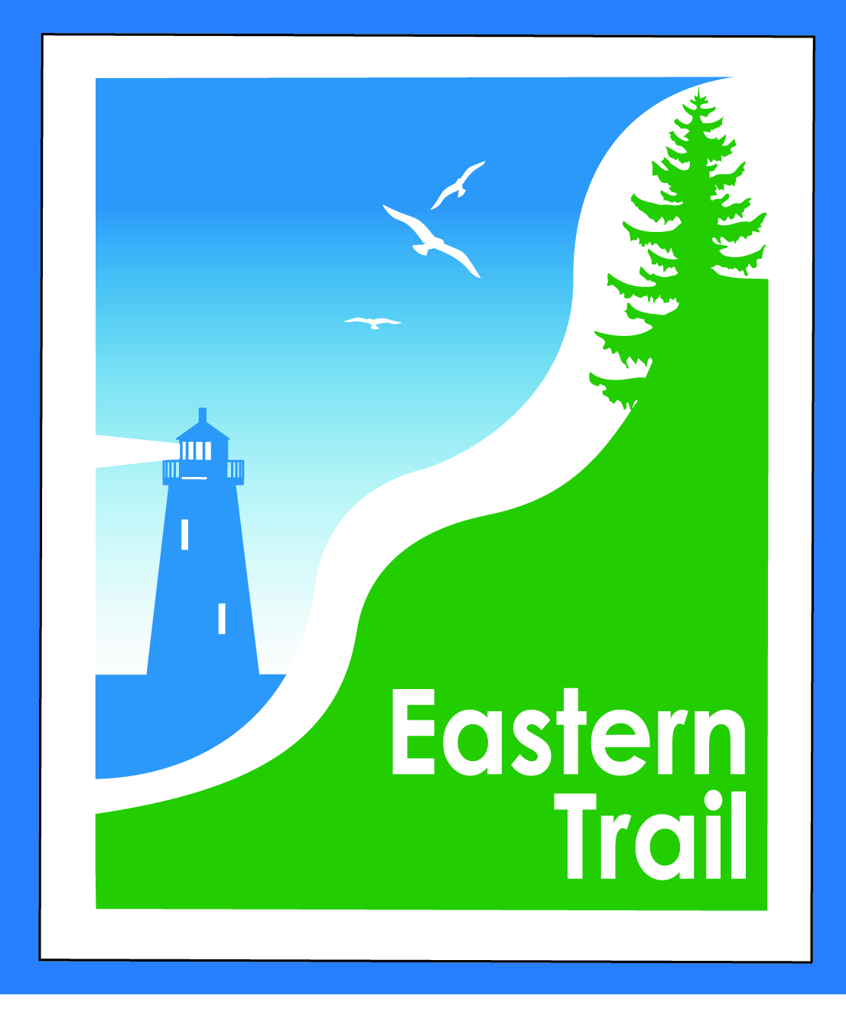

ETMD Board of Directors
Minutes
February 14, 2018

In attendance:
- Officers: Bill Reichl, President; Eric Labelle, VP; Bob Hamblen, Secretary.
- Trustees: Marianne Goodine, Wells; Joe Yuhas, ETA; Tad Redway, Arundel; Val Camire, OOB; Greg Tansley, Biddeford.
- Staff: Carole Brush, Executive Director

- Welcome & Introductions – Pres. Reichl opened meeting at 8:30.
- Arundel Conservation Trust Presentation – Leia Lowery, Linda Zuke—formed about 1 year ago, morphed from subchapter of Kennebunkport Conservation Trust. Arundel has been a divided community, hope this may provide a sense of community. Over 100 acres under management. Have an easement to the Kennebunk River, near where new town hall will be built – to be voted on in June. Parking at town hall upsized to include parking for ET users. Will be direct trail to ET, and other trails, too. Public restrooms will be included. Trails will probably be on line prior to town hall being done. Less than 1 mile from town hall site to ET. Some trails will be bike friendly, some less so. Trail to river, probably a footpath. KCT owns 2,400 acres, and pays taxes as a gift to town. Greg: might Town maintain trail? Probably not, would maintain road to trail. A lot of For Sale signs in Arundel, lot of properties will change hands and development likely to follow. A June fundraiser is planned. Ready to begin trail building when snow melts. Carole: will put you in touch with Unitil. Stimulus funds were used, so certain standards must be met at connection of your trail with ET. Website at Arundeltrust.org. Bill: we can grant you an easement over our easement prior to connection. Will cross the Unitil pipeline.
- Southern Maine Planning & Development Presentation – Paul Schumacher – got a grant in 2015 to get started. Group that included land trusts, snowmobile group, hikers and others got together, and a result is the map provided this morning. We need a backbone – the ET forms that, crossing entire county. Focusing efforts on existing trails, and where connections can be made. Have identified several possible connections. Opportunity to go from York River, through York Water District land, though they prefer to go under radar. Mt. A trail system has probably 30-40 miles of trails. ET off-road trail is nearby. Snowmobilers have a simple approach, good at approaching landowners. Group in Bethel follows that model – seek easements and agreements rather than expense of acquiring properties. Next, a Maine Community Foundation grant, allowed SMPDC to provide small grants to other groups. Kennebunk Plains are not far from the ET. Goal is something that will allow foot traffic from ocean to points inland. A smaller Maine Coast Heritage Trust grant came along, allowing current efforts. Working with landowners and small groups to move forward. With the ET making progress heading south into Kennebunk and Wells, a good time to raise awareness, and check back in with groups working on easements. A 45 mile trail is being developed from Unity to Belfast – handshake agreements. Have website showing trail system. Have seen a white paper, with 5-6 ways of creating trails. Have you seen use of TIF money for recreational trails? Statute allows it. Waterboro has done it, would allow off-road trails, for all users. On March 13, meeting will be bringing attendees up to date on progress, what can happen next. Carole: have an e-mail of intent from Unitil, they want next level of design to happen before a full co-lo agreement is drafted. Unitil not inclined to grant easement on unimproved portions of ET.
- Minutes of January 10, 2018 (to follow) needs vote – motion to accept, unanimous.
- Financial
  - January report (to follow)- needs vote – Carole, Val – unanimous, to accept as presented.
  - Dues Status – Scarborough has paid dues for upcoming year.
- Operations – 25 min
  - Review / discuss current and future Event Policy – Bill, Carole – bring to managers, discuss next time. Policy in minutes from months ago was no fee for non profits, for profits would be $100, plus $10 per participant. Agreed upon exception was for groups under 500, the fee would be $5 per participant…. Seems to be excessive, but which policy do we want to put forth? Prior policy was $500 flat fee, $100 for non profits. To some extent this has been an OOB-Scarborough situation. A fee helps to keep costs down, is our line. Revisit next meeting.
  - Review / discuss Trademark status and future policy – Bill, Bob H – we have the Eastern Trail name trademarked. Not logos. So, we’ve protected use of the name, advantages of it being trademarked aren’t fully clear yet.
  - Update – Arundel-Kennebunkport Cottage Preserve – Carole – talked to Joe Paolino yesterday, also asked about a possible ETA donation. He has invoice, haven’t seen check yet.
- Ongoing / Proposed Projects - 25 min
  - Close the Gap - Scarborough – 019386.00 – Bill, Carole – HNTB working on design, should be done in 1-2 months with mapping. Still environmental, acquisitions to go. Lucky to advertise in early 2019, perhaps summer start, work into winter. HNTB has advised MDOT of that. It is a LAP project, if MDOT project would be moving faster. Carole: money still flowing into coffers.
  - Blazing the Trail South - Kennebunk – South Berwick – Marianne, Eric, Carole – about 7.5 miles now surveyed. Chris Osterrieder, Kennebunk town engineer. DOT provided partial funding for survey. Would like to see a product closer to construction design. The data so far is good enough to begin design. Patrick Adams is cooperative, but they’d still like to see construction sooner than later. Carole: still make sense to seek grant money? Chris: I think so. Makes sense to meet with Marty at MDOT, will cost over $100,000 to get to that design point, or, do we spend money on further survey? Sebago data is very good, seems to surprise Unitil whenever we share it. Paul: please include Tom Reinauer from our office. Carole: we can point to Commissioner’s recent support, and further fundraising when we meet with Marty. Paul: planning to apply for next round of PPI grants? Chris: Marty has said he’d like to see progress toward design, which we can do. We did 30-30-40% last time, which worked well.
Paul: extends up into Three Rivers area, have given town of Lebanon a small grant to do some work. Lot of interest in Sanford, led by Lee Burnett. Sue at Wells Reserve has reconstructed entire trails maps, making it available, while we remain hesitant about showing trail connections on private property. On March 13, SMPDC hosting a meeting at Wells Reserve, 9-11 a.m., county-wide trails, making connections. Bob: get in touch with Jim Tasse at BCM re: mountain bike trails.
  - Over the River – Saco-Biddeford connection – Greg, Bob H, Carole – Greg: problematic from TA to Southern Maine Health Care, all on road. Rte. 1 in Saco, Biddeford is not easy. Manager Bennett has asked that this become a priority. Bob, Carole and I have met to discuss. Will involve Pan Am, as it’s in their corridor. Rails with Trails happen frequently. River crossing a hurdle, whether we cantilever off existing RR bridge, or build a new bridge. I was told to prioritize. The three, plus Paul Niehoff plan to walk it, Tad interested, too. Carole will reach out to Nate Moulton, MDOT, too. Bob: should include legislators, and MDOT, in order to effectively communicate with PanAm.
  - Reports from Municipalities -- Eric: looked into rights in Emmons Road situation. Landowner has been concerned about access.

- Outreach & Events – 15 min
  - EIS – Jim not in attendance, so will wait.
  - Upcoming ETA / ETMD events – Carole – Taste of the Town gala, and ETA fundraiser, coming up on April 7, at Camp Ketcha. Joe leading a walk behind SMHC 1-3 p.m., Feb. 19, President’s Day. Carole distributed list of events.

- Other Business? None.

- Next Meeting – March 14, 2018

- Adjourn: motion by Tad, 2nd by Bob, all in favor.

