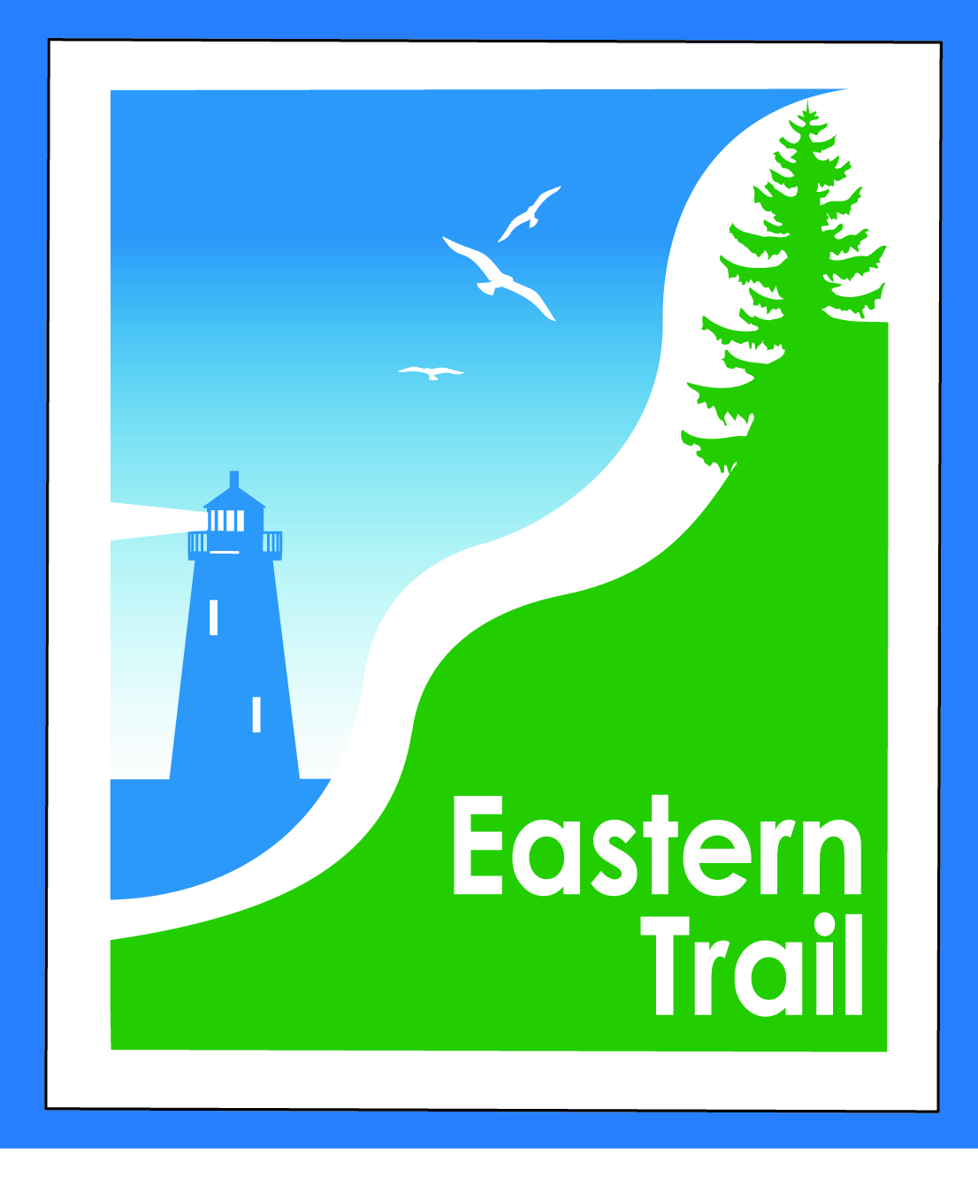

ETMD Board of Directors Meeting Minutes
Meeting Minutes - February 20, 2019

Officers: Val Camire, OOB, Treasurer; Marianne Goodine, Wells, Secretary
Trustees: Greg Tansley, Biddeford; Joe Yuhas, ETA; Jim Bucar, ETA; Tom McCullum, South Berwick
Staff: Carole Brush, Executive Director – ETMD, Nancy Borg, Executive Director - ETA
- Welcome & Introductions – 8:30 a.m.
- Minutes of January 9, 2018 – Motion by Val to accept minutes as written, 2nd by Jim. All in favor.
- Financials – January Report: – Val reviewed expenses for Month of January. We are still running under budget. Motion by Tom to accept financial statements, 2nd by Joe. All in favor.
  - Dues status – North Berwick reports no current funding for trail but has placed article on ballot asking voters for $3,500 for dues. They are in support of obtaining grant $$.
  - South Berwick – Has backed out and will not pay their $3,500 membership dues to ETMD, but instead place it into their own account for future trail and Great Works River Covered Bridge project. GWR Bridge supporters have raised $65,000 so far for covered bridge project.
- Operations:
  - Review of IronMan Agreement – ET’s attorney came back with revisions to the IronMan agreement amending the following: There is no assignment of when ETMD gets paid. Provisions include ETMD apply for “yearly grant” to IronMan Foundation for $5,000. They also require ETMD to have auto insurance. Carole will look into auto coverage and cost with our insurance. Group was ok with changes. Motion by Jim to approve agreement with suggested revisions to be resolved, 2nd by Joe. All in favor.
  - Kiosk enhancement project – Jim reported that kiosks are in various conditions of deterioration. He is currently looking into costs & dimensions for repairs. Suggested we update literature with new & important information to be posted on both sides of kiosks. Information should include upcoming events, geographic info, and seasonal info, i.e. hunting, equestrian, alerts, etc.
  - Thatcher Brook Watershed Signage on ET – Whitney Baker contacted Carole regarding outreach project for the Watershed to help improve water quality. She is working on signs to post on E.T. on either side of trail that crosses over Thatcher Brook. Group agreed that stakes should not be used and that TB signs should be attached to ET mile marker posts. Greg to work out details with Whitney.
  - ECG Proposal to ET – Sue Ellen Bordwell & Dick Woodbury from ECG approached Nancy & Carole to see if ETA/ETMD would be interested in extending the ET north from Bug Light all the way to Augusta? Would ETA be interested in acting as the “Fiscal Agent” for the St. Lawrence & Atlantic (Portland to Yarmouth) trail as they begin their fundraising campaign? This would involve ETA being the recipient and manager of funds for the project. There are many questions still to be answered and group was very hesitant about taking this on. Interesting in concept, however adding on to the north would make plans for adding trail in the south “go south” and not in a good way. ETA & staff already tapped out without adding another responsibility for ETA to manage. It was suggested that there are other organizations that can act as Fiscal Agent such as (GPCOG) Greater Portland Council of Governments, or (PACTS) Portland Area Comprehensive Transportation System. This is still very premature at this point. All agreed that it is too much to take on but we would be happy to provide a letter of support for their project.
  - E-Bikes – ETA was approached by Central Maine E-Bike on whether we allow E-bikes on trail. We do not have anything yet. There are three (3) classes of E-bikes; (1 & 2) -20 mph, (3) – 28 mph. 1 & 2 are applicable to use on the trail but currently we do not permit motorized vehicles on the trail. If Unitil does not allow, then we cannot allow. However, we do need to be cognizant of ADA. Carole to speak to Roger Barham at Unitil to get his take on it. It was suggested to draft policy on E-Bike use on the trail.
- Ongoing / Proposed Projects:
  - Close the Gap - Scarborough – 019386.00 – Project is still on track. Going to bid in the spring, design by June/July with construction shortly thereafter. Completion in 2020. Tom Hall & Karen Martin working on Press Release to release once project goes out for bid in the spring. There are some funds leftover for marketing which will be used for posters for kiosks which will include trail timeline info for Close the Gap and also a revised poster for the ET showing all three current projects.
  - Blazing the Trail South - Kennebunk – South Berwick –- Carole, along with reps from Kennebunk & Wells, met with MDOT a couple weeks ago and they also met the new Commissioner & were able to thank the retiring commissioner in person for the huge amount of support under his administration. It was a highly productive meeting which brought up some interesting new approaches. Kennebunk Savings Bank is highly interested in being a funding partner for the Kennebunk south section. KSB owns a parcel adjacent to trail at Alewive Road which we may be able to use as right of way for trail connection. Plans are to finish Kennebunk section and start survey work in Wells. Town engineers from Wells & Kennebunk to work on updating costs, identifying easy to construct sections and provide input to Carole. Kennebunk will get this information to Carole end of this week. When received, Carole to set up meeting with KSB to discuss options. Carole to work on applications for upcoming grant opportunities due this spring.
  - North Berwick: Tad has suggested working on something to present to N.B. Sanitary District. Greg to follow-up with Tad. Funding is still the issue. It would be logical to extend survey to Pratt & Whitney. Carole to reach out to Pratt & Whitney for possible interest in funding survey work.
  - South Berwick: Need more exposure in south to spark excitement for the trail. Group spent a considerable amount of time during the meeting discussing N.B. and S.B. membership & funding issues and ideas for possible solutions to bring them back on board. One suggestion was to include Close the Gap Press Release in southern publications: The Weekly Sentinel, Seacoast On-line and Foster Daily Democrat.
  - Over the River – Saco-Biddeford Connection – Unitil sent draft letter of support to Saco for use in reaching out to Pan Am. Meeting with Pan Am TBD. Greg recommends holding off for few months until cities get through budget season. Greg mentioned with the Maine Turnpike widening project, it may result in the State allocating funds towards trails.
  - Reports from Municipalities - None

- Outreach & Events:
  - Upcoming ETA / ETMD Events:
Event details on ETA website https://www.easterntrail.org/index.php/trail-events/events-calendar

- March 19 & 21 ETA booth at UNE Health Fair, Biddeford & Portland - Joe Yuhas
- April 6th 2nd Annual Taste of the Town Gala, Camp Ketcha, Scarborough
- April 13th Opening Day for Trails - ETA will do an event - yet to be determined
- April 19th ETA booth at Laudholm Farm for Earth Day events – Nancy Borg
- May 8th ETA Annual Meeting, Vinegar Hill Music Theatre, Arundel
- May 18th 3rd Annual JA 5k, O'Reilly's Cure-Eastern Trail, Scarborough
- September 7th 16th Annual Maine Lighthouse Ride
- September 22nd Autumn to Ale 10K - Eastern Trail, Scarborough

- Other Business – None

- Next Meeting – March 13, 2019

- Adjourn – 10:25 a.m. Motion by Nancy to adjourn, 2nd by Val. All in favor

