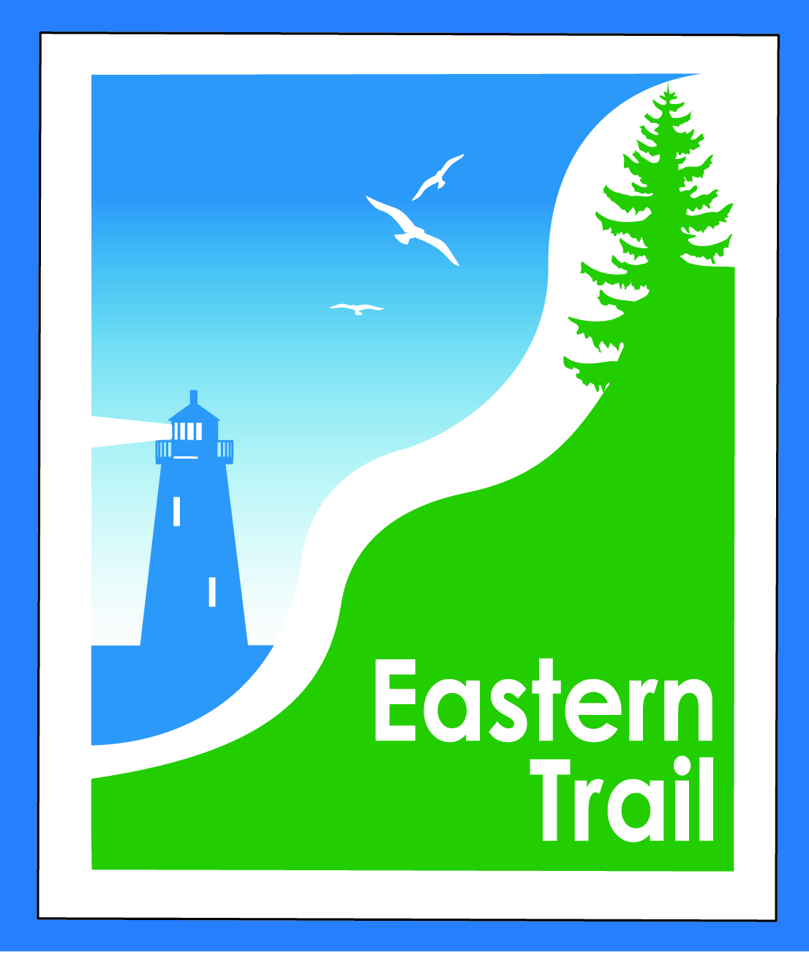

ETMD Board of Directors Agenda
Kennebunk Town Hall - Third Floor Conference Rm – March 14, 2018 - 8:30 – 10:30 a.m.

NO MEETING – POSTPONED UNTIL APRIL DUE TO SNOW

- Welcome & Introductions – 5 min
- Minutes of February 14, 2018 (attached) needs vote - 3 min

- Financial – 5 min
  - February report (attached)- needs vote – Carole, Val
  - Dues Status & Municipal Outreach – Carole
- Operations – 25 min
  - Current and future Event Policy – comments from Town Manager – All
    - Discussion and vote
  - Update – Arundel-Kennebunkport Cottage Preserve - Carole
- Ongoing / Proposed Projects - 25 min
  - Close the Gap - Scarborough – 019386.00 – Bill, Carole
  - Blazing the Trail South - Kennebunk – South Berwick – Marianne, Eric, Carole
  - Over the River – Saco-Biddeford connection – Greg, Bob H, Tad, Jim B, Carole
  - Reports from Municipalities

- Outreach & Events – 15 min
  - EIS - Jim
  - Upcoming ETA / ETMD events - Carole

- Other Business? – 2 min

- Next Meeting – April 11, 2018

- Adjourn

