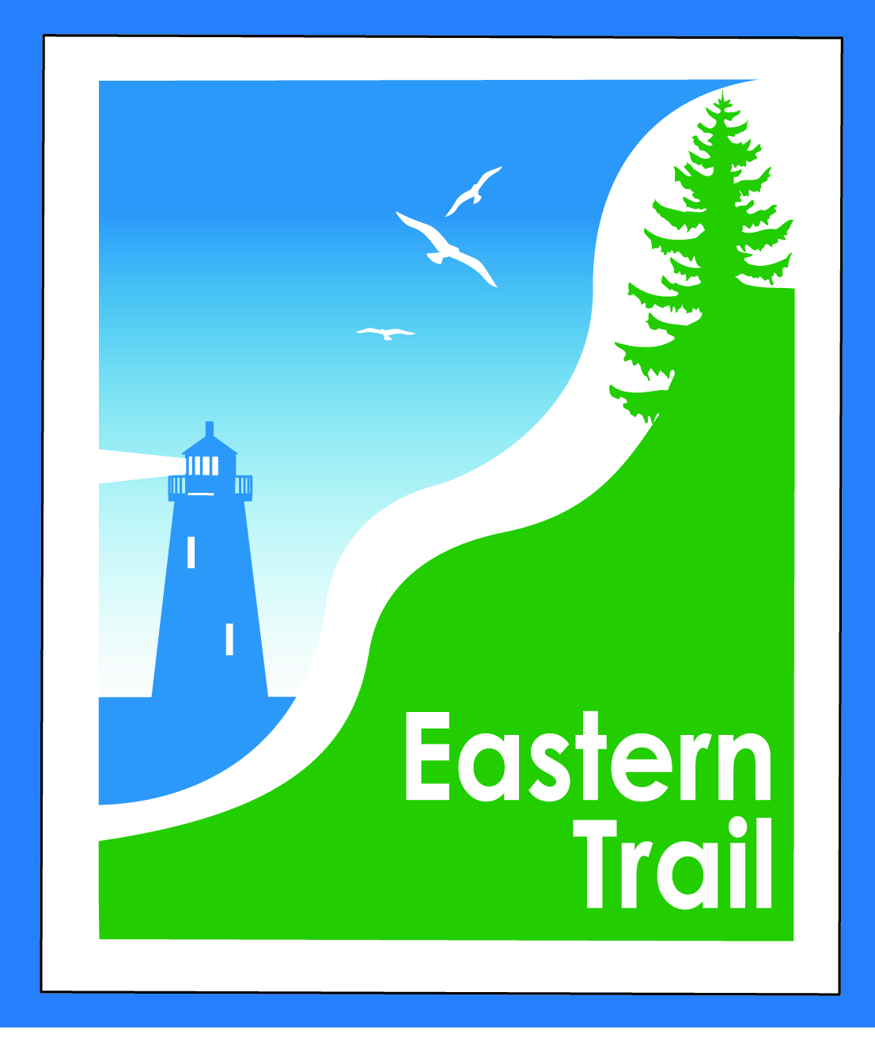

ETMD Board of Directors Agenda
Kennebunk Town Hall - Third Floor Conference Rm – May 9, 2018 - 8:30 – 10:30 a.m.

- Welcome & Introductions – 5 min
- Minutes of April 11, 2018 (attached) needs vote - 3 min

- Financial – 5 min
  - April report (attached)- needs vote – Carole, Val
- Operations – 25 min
  - Hallczuk status – Tad, Carole
  - Connection Updates – Tad, Carole
  - Arundel-Kennebunkport Cottage Preserve
  - Please review attached plan – requires our approval for Unitil to proceed
  - Arundel Conservation Trust
  - Please review attached connection agreement – requires our approval for Unitil to proceed
- Ongoing / Proposed Projects - 25 min
  - Close the Gap - Scarborough – 019386.00 – Bill, Carole
  - Blazing the Trail South - Kennebunk – South Berwick – Marianne, Eric, Carole
  - Over the River – Saco-Biddeford connection – Greg, Bob H, Tad, Jim B, Carole
  - Reports from Municipalities

- Outreach & Events – 15 min - Carole, Jim, Joe
  - ETA Annual Meeting
  - JA5k
  - EIS - Jim
  - Upcoming ETA / ETMD events - Carole

- Other Business? – 2 min

- Next Meeting – June 13, 2018 (Note: Election of Officers)

- Adjourn

