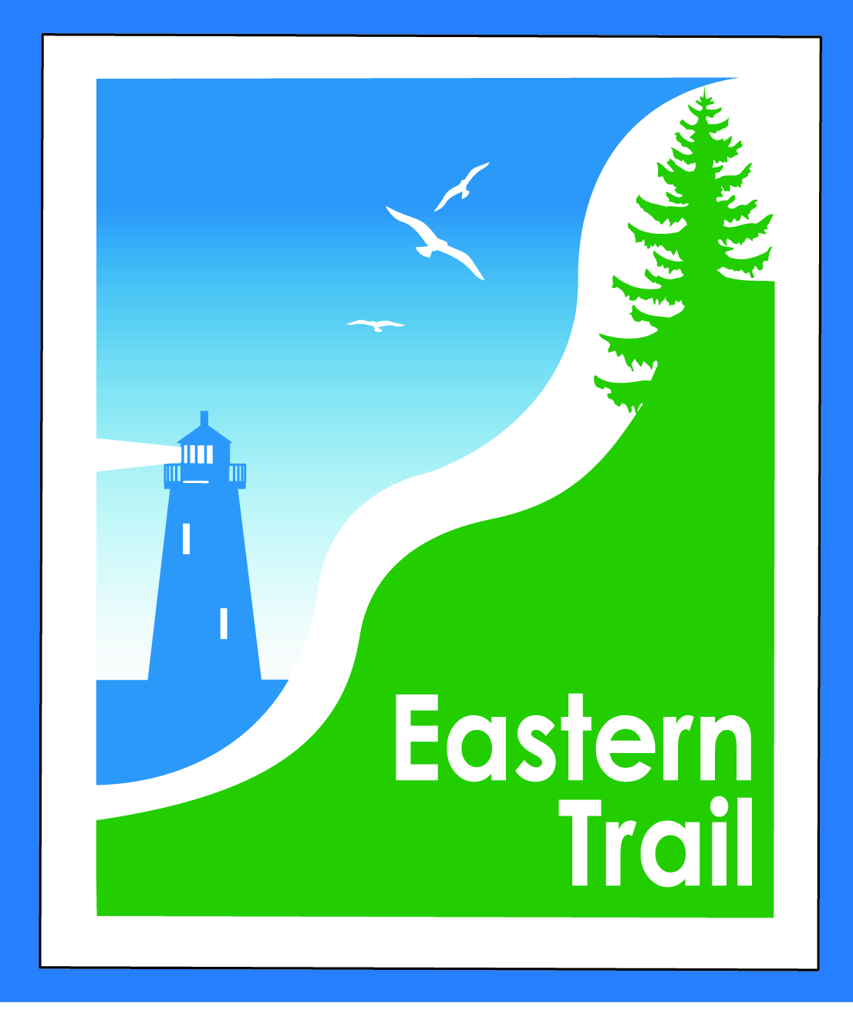

ETMD Board of Directors – Agenda
Kennebunk Town Hall - Third Floor Conference Rm – June 10, 2015 - 8:30 – 10:30 a.m.
- Minutes of May 13, 2015 attached – needs vote - 3 min
- Financial Report – Carole (will follow) – needs vote – 2 min
  - Review of 2016 proposed budget – Marianne (will follow) – needs vote - 15 min
- ETMD Priorities 90 min
  - Election of Officers - Tad
  - Management Policies & Procedures
    - Future ET planning – Tad / Carole
      - 2015 Dues (2nd notice sent 6/05) – Status report from municipalities
      - Status Kennebunk, Wells, Unitil
      - Funding Sources and strategies – Carole
    - Trail Maintenance/Repairs – Tad
      - Review of 5/28 Maintenance Meeting Notes (sent 6/04)
      - Next steps
    - Reports from Municipalities
- Ongoing / Proposed Projects: 10 min
  - Scarborough – 019386.00 Bill R
    - $150,000 .8 mi. design update
    - Pleasant Hill Rd – SoPo town line update
- Outreach & Events – Carole/Bob H
    - Report on ETMD 2015 booked events, ETA Annual Meeting
    - Report on ETA Issues & Direction Workshop – Bob H
- Other Business – issues? Concerns? 5 min
- Next Meeting – July 8, 2015
- Adjourn

ETMD Board of Directors

Minutes, May 13, 2015

In Attendance:
Val Camire – Old Orchard Beach
Joe Yuhas – ETA
Jim Bucar -- ETA
John Andrews – ETA
Bill Reichl, VP – Scarborough
Edward Blais – Scarborough (Alternate)
Carole Brush – ETMD – Executive Director
Bob Hamblen – Saco

Meeting called to order at 8:37 AM

- Minutes of April 8, 2015 – Hamblen moves to accept, 2nd by John, all in favor.
- Financial Report – JA: question about KBS statement – ETMD has $60K in bank? Surprised. Is an alternative investment advisable, bearing greater interest? Bill: is ETA looking into it? John: yes, but knowing we’ll be spending soon, we backed away. Bob: maintenance spending may become necessary. John: Arundel section in need of attention. John: consider investing with Vanguard? Bob: what are our options? Carole: next month, new budget and election of officers – consider it then? John moves to accept financial report, 2nd by Bob, all in favor. Jim: funds being provided for various activities? Bill: yes, $2,000 to Scarborough for alternatives analysis, and $1,500 committed to OOB for paving short section by Old Cascade Road.
- ETMD Priorities 90 min
  - Management Policies & Procedures
    - Future ET planning –
      - Report on 4/29 internal planning meeting , follow up email to Unitil: Carole: Tad, Bob, Jon Carteer, Barry Tibetts and I met for pre-Unitil meeting strategizing. Jon Carter is about to send an e-mail to Unitil requesting a meeting, re: co-location agreement.
      - 2015 Dues – Status report from ETMD representatives. Bob: Saco will pay after July 1. Carole: Scarborough has paid. Val: OOB is fine with it. Carole: not sure where South Berwick stands.
      - Funding Sources and strategies – Carole: federal and state sources not improved. Have distributed a list of possible sources. ETA has contracted with a grant writer, have submitted a first LOI to Quimby Family Foundation. Any problem with ETMD seeking grants? John: not that we’re aware. Bob: those offering grants will tell you. Carole: the Quality Community grant program allows applications any time. Will check as to status of Kennebunk and Wells applications: dead in the water, or in a queue?
    - Trail Maintenance/Repairs – Tad
      - Maintenance Meeting set for May 28th – Scarborough 11 – 1
        - Response from ETMD representatives on confirmed attendees – Saco will attend. Bill Robertson, OOB, has retired. Val has asked Larry Mead who might attend. Scarborough: Mike Shaw and Bill will attend. John: Desfosses section trail needs attention. Carole will follow up with Arundel, South Berwick, Wells and Kennebunk re: attendance.
      - Signage - Trail Etiquette, ER markers, Kiosks, US Bike Route 1 status - Carole/Jim: signs are up in all towns. Some ER mile markers still missing. Val: paving will be done after Memorial Day weekend at Old Cascade Road. Jim will attend if schedule can be found out. Mileage signs: need to identify the missing ones and have new metal ones made. Val: OOB can fabricate them, if ETMD can cover costs. Carole: U.S. BR1 – behind on sign installations. MDOT on-road, PACTS off-road signs to be installed. Met with South Portland, Sabrina Best, who is overseeing this. Hoping to add ET to Greenbelt signs, and to kiosks. John: mileage problem will crop up. When SoPo-Scarborough connection gets done, will throw mileage off. Mile 0 will be in Casco Bay. Jim: they don’t have to be accurate; they’re for safety.
    - Reports from Municipalities – Bob: fissure in section between Moody Street and JRA Bridge, Saci has informed Unitil. Bill: picking up branches, etc. Culvert on Blue Point Road has been freed up. Carole: poison ivy patch just past bridge toward Black Point Road. Bill: can’t spray in Marsh. Jim: perhaps put up a sign of warning. John: Kerry Anderson culvert issue. Installed under trail near Black Point Road, trail surface now broken, just before Sullivan’s house. Bill: Anderson’s about to put in sidewalk that will be the trail for that section. Porta-potty by public works will be moved closer to trail.
- Ongoing / Proposed Projects:
  - Scarborough – 019386.00 Bill R
    - $150,000 .8 mi. design update -- Bill: HNTB doing alternatives analysis from Nonesuch River to SoPo. If Pond View Drive, then existing man-made ditches are regarded as streams. CMP is current holdup. Woman in charge now back in office. Roger Hale supports alignment around pond. He has easement from Portland Water District for access, then across trail. Data sent to Army Corps for its review. Will meet with DOT and DEP hopefully this month. Hoping to build this year. Work being done there by Dearborn Construction, and they’ve expressed interest in trail work. Wainwright to Pleasant Hill Road section.
    - Pleasant Hill Rd – SoPo town line update – see above.
- Outreach & Events - Carole
    - ETMD 2015 booked events – Carole: Harvest Half Marathon probably not going to happen again. Alex’s Walk going again this year, not next year. So, about $450 less income will be coming in. When fewer than 50 participants, we haven’t charged for permit. Sooper Dogs doing a ‘walk your dog’ event on May 31, have asked for a waiver of insurance requirement. Tim Lambert, ETA Trustee, making this happen. $350-400 for a one day event like this. John: also sponsors of MLR. Bill: only concern is trail user being bitten by dog. If you know it’s going on, they can come back at you if injury occurs. Bill: Bike for Books was required to get insurance in Scarborough. Carole: will find Greg Tansley and start with him re: Sooper Dogs event.
    - ETA Annual Meeting – May 14th – Carole: come to annual meeting, Old Marsh country club, Wells, tomorrow evening. Speakers: what is happening in York County for trails in addition to the ET.
    - ETA Strategic Planning Process – Bob H. describes process about to begin with consultant Malcolm Poole. Other groups have gone thru similar processes, and found it very helpful.
- Other Business – issues? Concerns? Jim: have seen maintenance concerns on trail, in Saco: fissure, and at curve by Sweetser. Can towns put up cones or signs as warning? Bob: will check with P&R. Carole: MDOT has put out notices of upcoming Bike-Ped group meeting, May 27, in Augusta, 3-5:30. Carole, John and Jim plan to attend. Joe: SETA decided to contact rec departments, invite to visit trail via bus, and SETA would provide volunteer leaders. Kittery is interested, also invited to ETA annual meeting. Destinations to be determined. Bob: CHCC annual meeting on May 20, several attending, will report back. Carole: new Apple laptops in, working well.
- Next Meeting – June 10, 2015 – budget and officers.
- Adjourn – John moves to adjourn, 2nd by Jim, all in favor, at 10:05 a.m.

