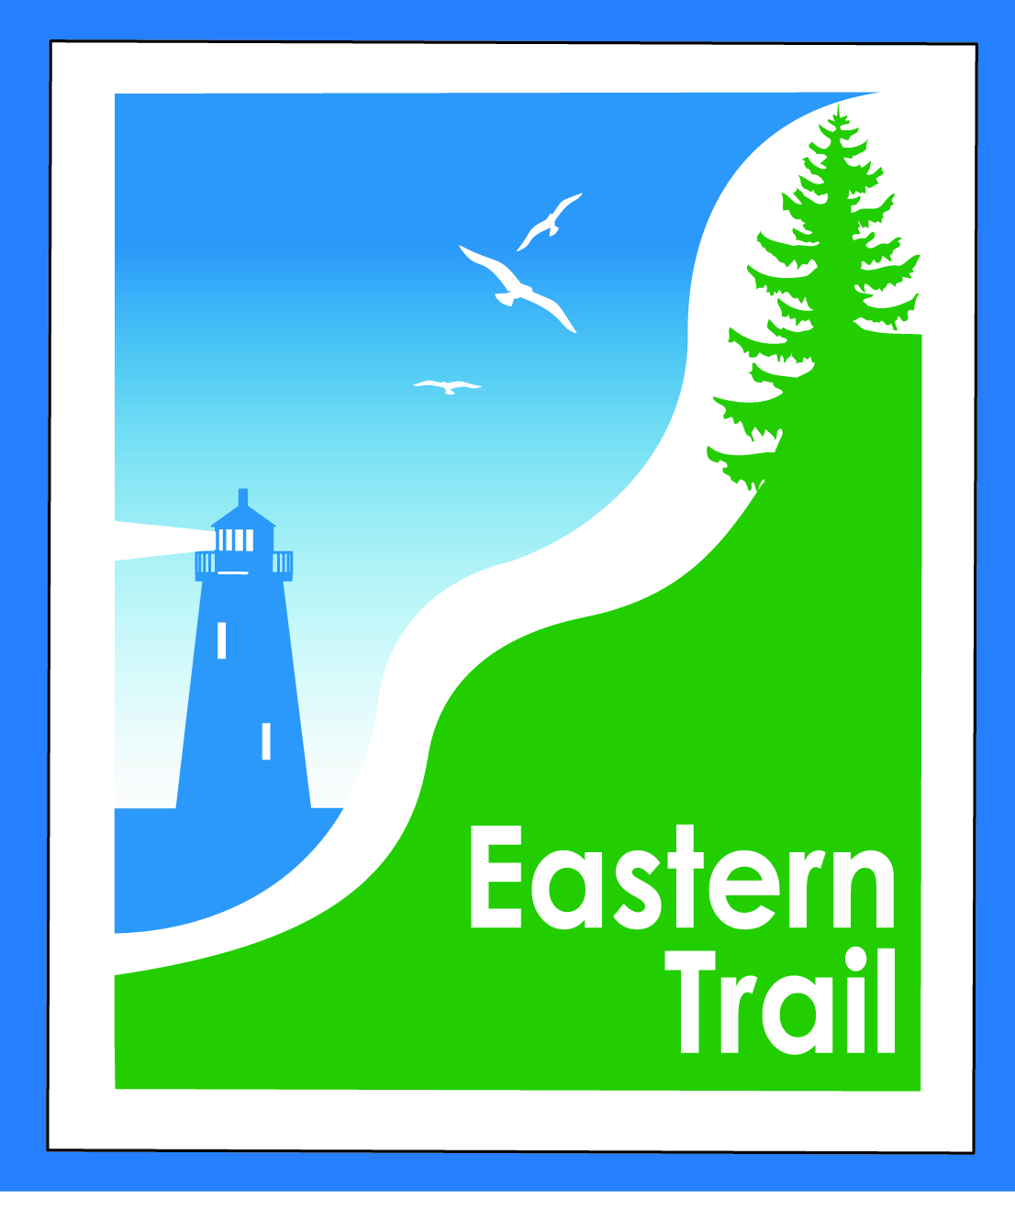

ETMD Board of Directors Agenda
Kennebunk Town Hall - Third Floor Conference Rm – July 11, 2018 - 8:30 – 10:30 a.m.

- Welcome & Introductions – 5 min
- Minutes of June 13, 2018 - needs vote - 3 min

- Financial – 5 min
  - June report - needs vote – Carole, Bill
  - Budget for FY 2019 – draft attached - discussion – All
- Operations – 25 min
  - Dues status – Carole
  - Connection Updates – Tad, Carole
  - Trail improvements – kiosks, signs – Carole
  - ETMD Board – Trustee updates - Bill
- Ongoing / Proposed Projects - 25 min
  - Close the Gap - Scarborough – 019386.00 – Bill, Carole
  - Blazing the Trail South - Kennebunk – South Berwick – Marianne, Carole
  - Update from 7/5 Wells strategy meeting
  - Bike racks for South Berwick – Tom McC, Carole
  - Over the River – Saco-Biddeford connection – Greg, Carole
  - Reports from Municipalities

- Outreach & Events – 15 min - Carole, Jim, Joe
  - EIS - Jim
  - IronMan
  - Upcoming ETA / ETMD events - Carole

- Other Business? – 2 min

- Next Meeting – August 8, 2018

- Adjourn

