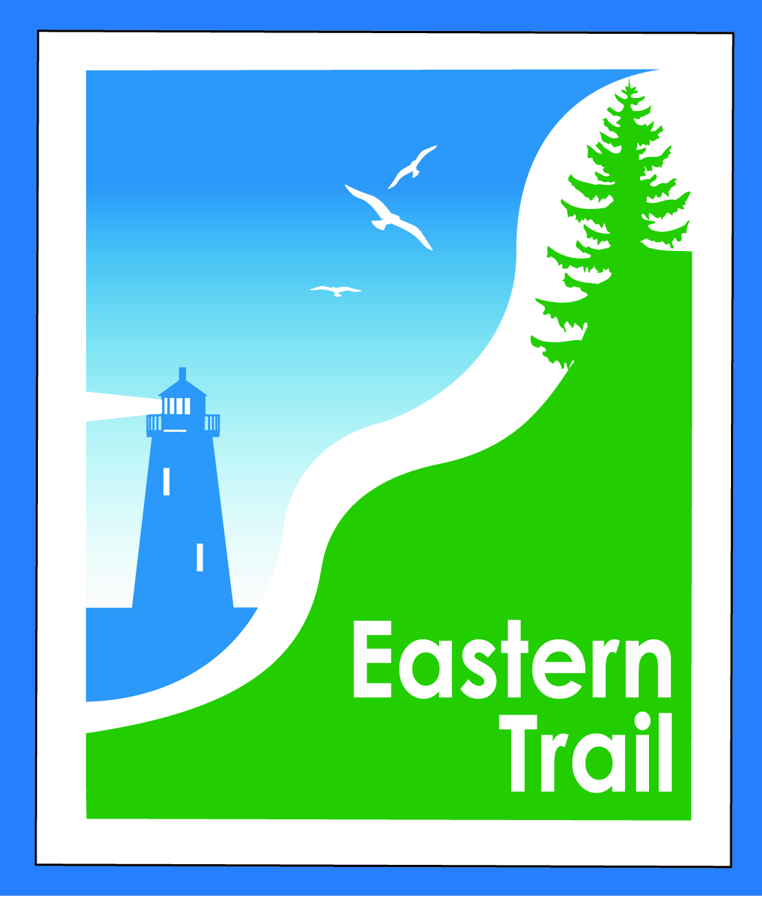

ETMD Board of Directors –Agenda
Kennebunk Town Hall - Third Floor Conference Rm – August 9, 2017 - 8:30 – 10:30 a.m.

- Welcome & Introductions – 2 min
- ETA – ETMD Budget Review – 45 min
- Minutes of June 14, 2017 (to follow) & July 12, 2017 (attached) needs vote - 5 min

- Financial – Carole, Val – 5 min
  - July report (attd)- needs vote
- Operations – 15 min - Carole
  - Dues status – Carole
  - Cape Arundel request for connection – needs vote

- Ongoing / Proposed Projects: 30 min
  - Scarborough – 019386.00 Bill, Carole
  - Status Kennebunk – Wells – Marianne, Eric, Carole
  - Reports from Municipalities
    - Arundel - Hallczuk dog incident

- Outreach & Events – 15 min – Carole
  - EIS update – Jim
  - Ironman – August 27th
  - August, September CTG & ETA events
  - Upcoming ETMD events – see tab on attached financial report

- Other Business? – 3 min

- Next Meeting – September 13, 2017

- Adjourn

