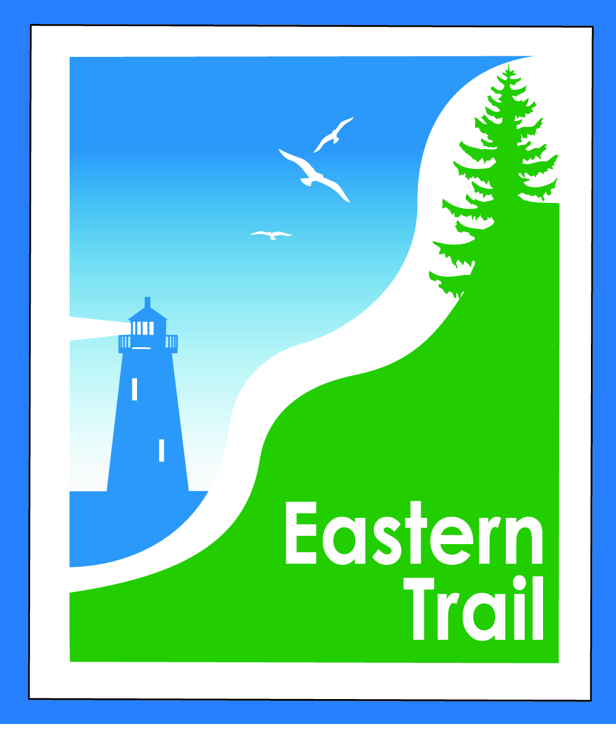

ETMD Board of Directors – Agenda
Kennebunk Town Hall - Third Floor Conference Rm – September 9, 2015 - 8:30 – 10:30 a.m.
- Introductions – 1 min
- Minutes of August 12, 2015 (incl) – needs vote - 2 min
- Financial Report for July, 2015 – Val/Marianne (incl) – needs vote – 2 min
- ETMD Priorities - 75 min
  - Management Policies & Procedures
    - Recent trail issues –Marianne/ Tad/Bill
    - Bench requests/policy – Marianne/ Greg
    - Trail Maintenance/Repairs/Municipal Reports – Marianne
      - Signs – directional and “thank you Unitil” – Bob
      - Maintenance Status Report (incl)
      - Reports from Municipalities
    - Future ET planning – Marianne
      - Outreach & funding
        - Unitil CLA status (report incl)
        - MDOT (report incl)
- Current Projects - 15 min
    - Kennebunk - design status – Tom M
    - OOB Spur trail – Jim B, Val, Megan
    - Scarborough – 019386.00 - Bill R
      - $150,000 .8 mi. design update
      - Pleasant Hill Rd – SoPo town line update
    - Wells – design status – Marianne
- Events – 1 min - Marianne
    - Report on ETMD 2015 events, estimate on 2016 events (incl)
- Other Business - 2 min – issues? Concerns
- Next Meeting – October 14, 2015
- Adjourn

