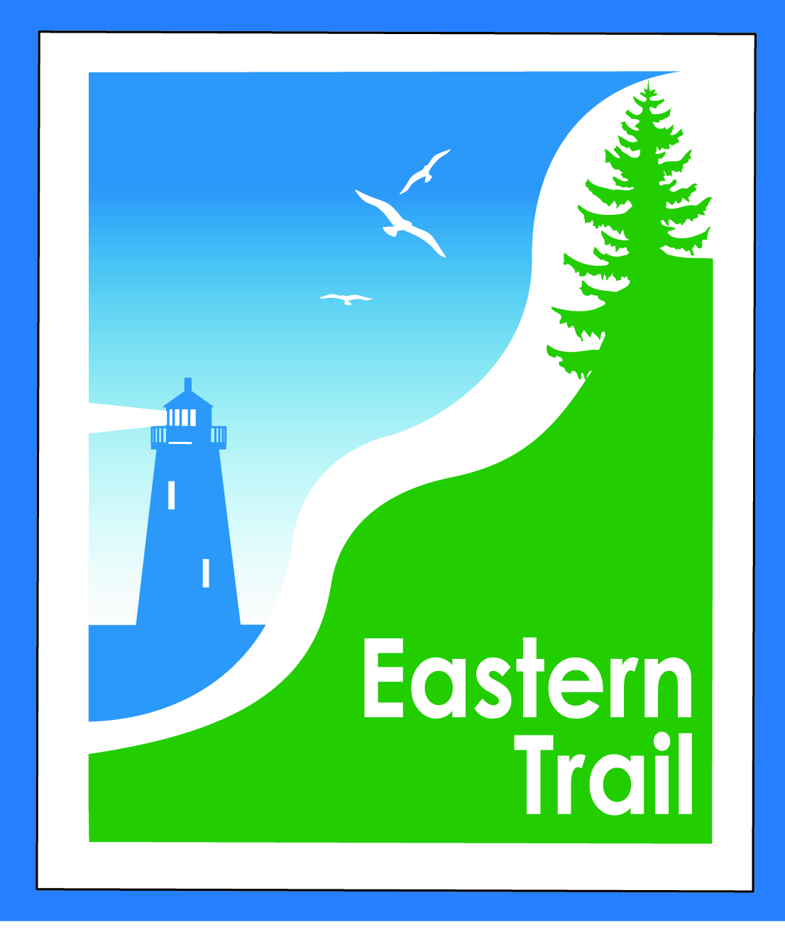

ETMD Board of Directors Agenda
Kennebunk Town Hall - Third Floor Conference Rm – September 12, 2018 - 8:30 – 10:30 a.m.

- Welcome & Introductions – 5 min
- Review of IronMan – 2018 & 2019 – Jason Webber, OOB – 30 minutes
- Minutes of July 13, 2018 - needs vote - 5 min

- Financial – 5 min
  - July, August reports - needs vote – Carole, Bill
- Operations – 25 min
  - Dues status – Carole
  - Connection Updates – Tad, Carole
  - Trail improvements – kiosks, signs – Carole
  - ETMD Board – Trustee updates - Bill
- Ongoing / Proposed Projects - 25 min
  - Close the Gap - Scarborough – 019386.00 – Bill, Carole
  - Blazing the Trail South - Kennebunk – South Berwick – Marianne, Carole
  - Overview of status & discussion on strategy
  - Over the River – Saco-Biddeford connection – Greg, Carole
  - Reports from Municipalities

- Outreach & Events – 15 min - Carole, Jim, Joe
  - EIS - Jim
  - IronMan Recap (above)
  - Upcoming ETA / ETMD events – Carole, Joe

- Other Business? – 5 min

- Next Meeting – October 10, 2018

- Adjourn

