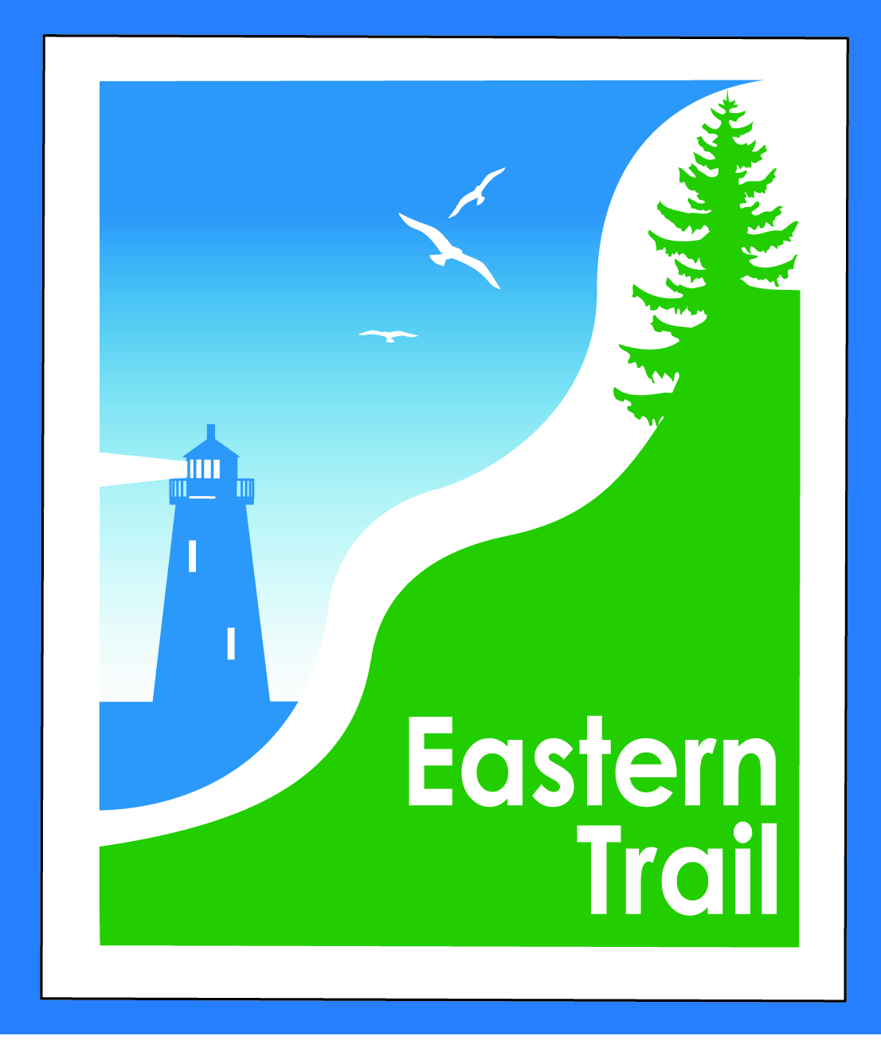

ETMD Board of Directors – Agenda
Kennebunk Town Hall - Third Floor Conference Rm – September 13, 2016 - 8:30 – 10:30 a.m.
- Minutes of July 13, 2016 (included)– needs vote - 2 min
- Financial Report – Carole (July, August included) – needs vote – 3 min
- ETMD Priorities 75 min
  - Trail Operations/Maintenance priorities
    - Update: Arundel: Ban Billy from trail – dog bite incident
    - Bollards
      - Need to address recent complaints re ADA accessibility
        - $2500 received by ETA for bollard relocation will transferred and should be used by ETMD to relocate problematic locations
    - Maintenance: (from July – any updates?) Saco: ramp by Sweetser; Kennebunk: ramp by MTA bridge, spur trail; KAB: critter/sink holes; Arundel: kiosk plexi glass, broken fence rails (Hidden Meadows/Bass La area); All: Mow/weed whack; Other?
  - Dues Status: All in but South Berwick- anticipated in October
- Ongoing / Proposed Projects: 23 min
  - Scarborough – 019386.00 Bill R, Carole B (grassroots)
  - Status Kennebunk – Wells – Marianne, Eric
  - Reports from Municipalities
  - SMPDC spur trail project - Carole
- Outreach, amenities & Events – Carole/Bob H
    - Water fountain-Saco; new artwork–Biddeford
    - Report on ETMD 2016 booked events
- Other Business – issues? Concerns? 2 min
- Next Meeting – October 12, 2016
- Adjourn

