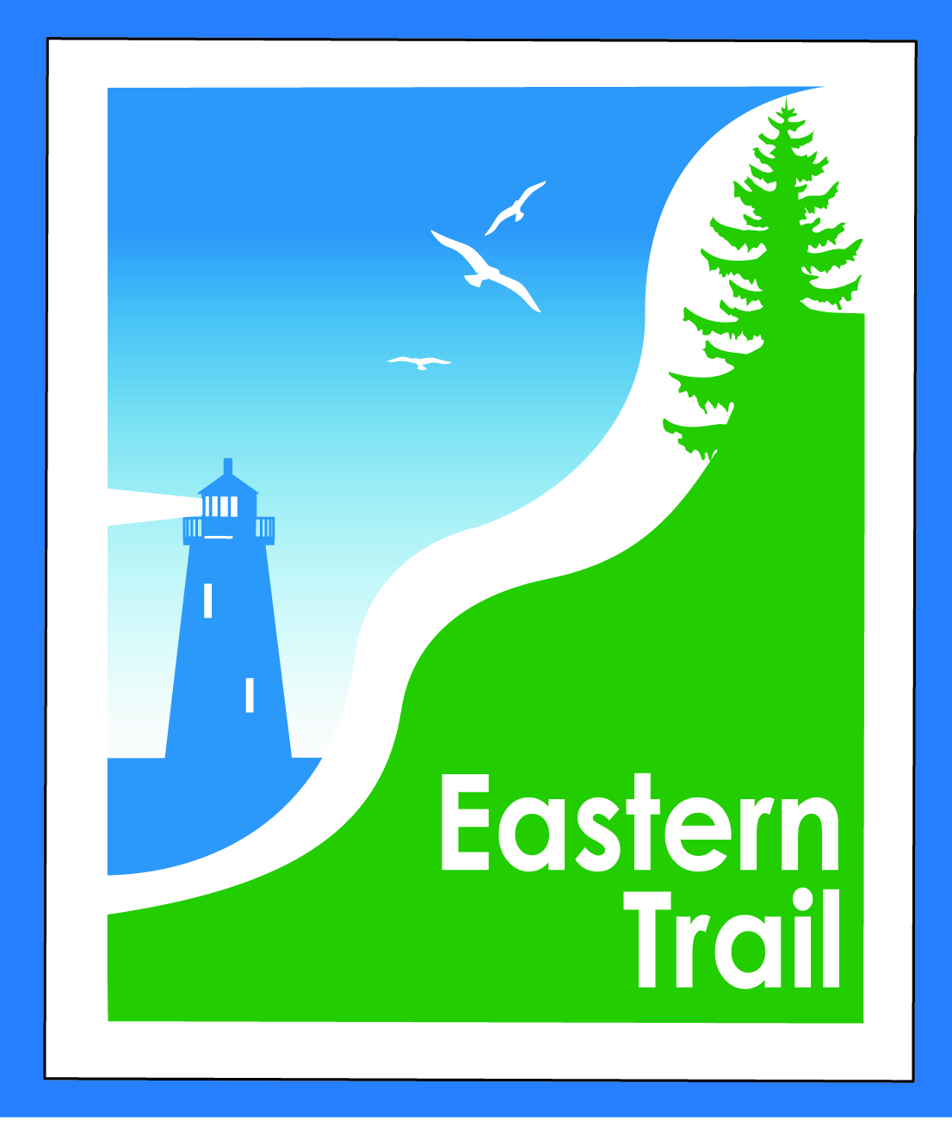

ETMD Board of Directors –Agenda
Kennebunk Town Hall - Third Floor Conference Rm –November 8, 2017 - 8:30 – 10:30 a.m.

- Welcome & Introductions – 2 min
- Minutes of October 11, 2017 (to follow) needs vote - 5 min

- Financial – 5 min
  - October report (to follow) - needs vote – Carole, Val
- Operations – 45 min
  - Action Item – Engage attorney re Hallczuk 12/5 hearing - Tad
  - Action Item - Respond to Cape Arundel request for trail connection – Tad
  - Status – Eastern Trail proposed development – Megan, Jim
  - Trail enhancements – Carole
- Ongoing / Proposed Projects: 45 min
  - Scarborough – 019386.00 Bill, Carole
  - Status Kennebunk – Wells – Marianne, Eric, Carole
  - North Berwick update - Carole
  - Reports from Municipalities

- Outreach & Events – 15 min – Carole

- Other Business? – 3 min

- Next Meeting – December 13, 2017

- Adjourn

