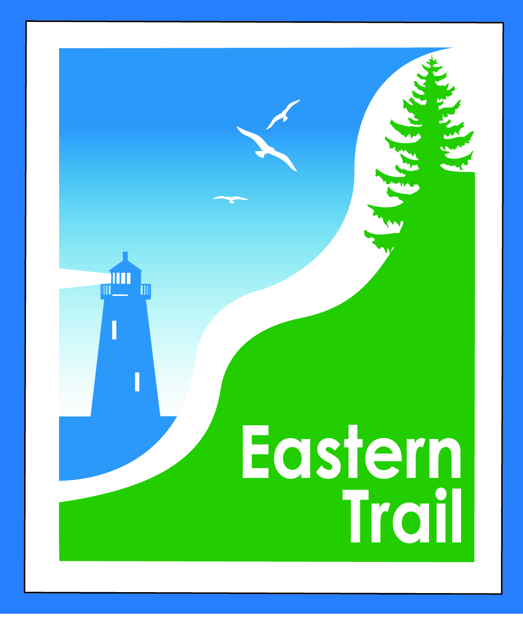

ETMD Board of Directors
Minutes November 8, 2017
- Officers: Bill Reichl, Scarborough; Eric Labelle, VP; Bob Hamblen, Secretary
- Trustees: Marianne Goodine, Wells; Greg Tansley, Biddeford; Jim Bucar, ETA; Tad Redway, Arundel; Val Camire, OOB
- Staff: Carole Brush, Executive Director

- Welcome & Introductions
- Minutes of October 11, 2017 – motion by Jim to accept as presented, seconded by Val, and so voted, 8-0.
- Financial
  - October report -- Carole, Val: Jim moved to accept as presented, seconded by Marianne, and so voted, 8-0.
  - Status financial appeal to ETA - Carole – ETA considering more hours for Carole, assuming some of ETMD needs. To be discussed more.
  - Action item – review mid-year budget status, set 2018-2019 ETMD dues fees – Bill, Val: at least $10,000 deficit projected. Bob: and yet, balance of $73,000 plus at KSB. What gives? Bill: using up reserve based on projected expenses, need to stem the tide. ETA meets next week, may finalize this shift of Carole’s hours to ETA. Tad: as a 501c3 we have fundraising capabilities. We can hold fundraisers, can hire a boilerplate operation, any number of things. If dues are only revenue source, that’s a losing operation. Carole: an ETA/ETMD event, co-produced? Bill: speaking for rec departments, it’s hard. If we sponsor another event, that takes away from other things we could be doing. Eric: don’t understand why we’re self funded, and not just a subset of ETA. We’re a maintenance organization, fundraising is not our forte. Tad: it started as raising funds to build, not to maintain. I see ETA as fundraising arm, and ETMD as the implementation arm. Carole: in the beginning, ETA had nothing. Tad: they were cheerleaders. Carole: at ETA, we’re looking to increase Nancy’s hours, and hoping to bring Jen on at 10 hours/week. She’d be working on Close the Gap and progressing south. Bill: can stay flat and hope we just have to eat $2,000 this year, or, increase dues by $250. If ETA doesn’t come through. Eric: motion to keep dues as is, seconded by Tad. Bill: if ETA doesn’t come through, we may have to go back to communities re: shortfall. Amend motion to re-evaluate as needed. Voted, 8-0.
- Operations
  - Action Item – Engage attorney re Hallczuk 12/5 hearing – Tad: Eric: just hired an employee, he got bit by a Hallczuk dog, too. Jim: a woman I met at senior event in Saco said she’s afraid to go on Trail because she’d heard about the dog. Tad: has Leah Rachin contacted anyone? She’s the town attorney. No one has gotten a call. Sheriff suggested an attorney. Town’s not pushing the issue – their issue is the dog. Criminal trespass is a private matter, between ETMD and Hallczuk. No one is pushing that issue. Judge was going to dismiss the case. Leah went to arraignment, DA and judge got together, mentioned a $200 fine and dismiss. Leah said we want to pursue. An ETA or ETMD representative needs to appear, or, we hire an attorney. They tried a plea bargain, Bill wouldn’t go on Trail any more, no dogs any more. Bill has a friendly attorney in N.H. When he gets in trouble, the attorney helps him out. Jim: we should secure an attorney, need to resolve this. Tad: would help town’s case if ETMD also had a case. Town trying to make sure he can’t keep dogs any longer. ETMD is trying to keep him off Trail. Bill is an imposing figure. Jim: does he have a history of mental illness? Not sure, probably a drug addiction problem. Jim: moves to retain an attorney, that someone from ETMD be present to represent the ETMD in court. Carole: Deb from ETA will attend. Jim: I plan to be there. I’m not an officer. Bill: one of us will try to be there, on Dec. 5. Tad will attend for town, code officer, too. Motion was seconded by Bob, and so voted, 8-0.
  - Action Item - Respond to Cape Arundel request for trail connection – Tad. Carole: been dodging Joe and Rick from Cape Arundel, they want to connect to Trail. Have asked ECGA whether charges imposed elsewhere, but no help. Tad: would subdivision in OOB pay a fee? They’re allowing two-way access. Bill: Kerry Anderson is building a path connecting to the Trail, and because traffic will increase, the path is a good thing. Tad: I’ve talked to Joe about the connection, east-west from Kennebunkport onto the ET. He’s got a product based on exclusivity and public access would interfere. KKW wants to put in a water tower, and owns an easement right next door. Might be available for public access to Trail. Eric: will depend on the language. Bob: should we send him a written access agreement with a $3500 fee attached? Jim: he’s making an investment, and the Trail is one of the attractions. A financial agreement will become a precedent. Carole: for any connection, or for only a one-way access? Jim: for any connection. Tad: we don’t technically sanction private access to the Trail. All we have to do is ask, and Unitil doesn’t have a concern, generally. Talbot Woods doesn’t have a subdivision access, but they use the Trail. Jim: who would negotiate with Cape Arundel? Tad: I can’t, I have a conflict. Jim: Carole can use, “I’ve been directed by the Board…” Will approach Tim Murphy and ask for an Access Easement. Meeting with Unitil re: co-location agreement on the 28th. Jim: could Cape Arundel sign on as a sponsor of the Trail, say a mile of Trail? Bill: what if we ask maintenance outfit for Cape Arundel to maintain that section? Agreement should include use of ET logo, official sponsor of ET, seconded by Jim, and so voted, 7-1 (Bill).
  - Status – Eastern Trail Estates proposed development, OOB – Megan, Jim: Jim went to meeting. Val: will ask Megan for status update. Bill: thought we approved access, two-way, at September meeting. Carole: minutes say yes, we did. Jim: consider an access agreement there, too. Using our name should carry a cost. Kevin Beaulieu, developer, would provide full public access/easement. Carole: Tim asked for three representations of our logo, but we have 2 lighthouses. Signs have other lighthouse on it. We will copyright both lighthouses, and term ‘Eastern Trail.” Jim: have they requested access of the ETMD? Carole: no. Perhaps a presentation to our board at the December meeting. What of value can we request? Bathrooms, water fountain? No. Parking?
  - Trail enhancements – Carole: charging for sponsorships of Trail – “this mile of Trail for $2,500,” and giving them the right to post their logo and name. Portland Trails has such a program. Their adopt a trail program has people maintaining the Trail. A revenue source, a yearly fee or in-kind support. Eric: an annual project was the approach, building a rain garden, for example. Or, a bronze, silver or gold sponsorship, in cash. Jim: can demonstrate to towns that we’re seeking other sources of income. Greg: annual, graduated fee. In-kind sponsors must provide services. Bill: why not try something simple like $1,000 a mile, and see if we can grow it from there? Eric: do their ads or signage appear on the Trail? Or on website? Kiosks? Greg: new president at UNE, he may be interested. Graduated levels will need further detail. Carole: a new kiosk in Biddeford would be a welcomed, sponsored addition.
- Ongoing / Proposed Projects: 45 min
  - Scarborough – 019386.00 Bill, Carole: little change. SoPo will talk to Roger Hale, but may have to eat a $75,000 increase due to realignment. So, back at $485,000 left to raise, would be upped to $560,000. Supposedly to be resolved in next month. Carole: meeting next week with Committee, may be time to return to MDOT and PACTS. SoPo has put up $26,000, their share of the PACTS grant. Is it time to ask both municipalities to raise more money? Have now engaged SoPo in a couple of ways, so that’s positive.
  - Status Kennebunk – Wells – Marianne, Eric, Carole: Marianne, meeting scheduled for 11/28, town planners and managers, and Unitil. Carole: Joe Yuhas presented to Pratt and Whitney. If Dwayne would come to a meeting, they’ll host it.
  - North Berwick update – Carole: Have received $5,000 from P&W, not sure what it’s intended for.
  - Reports from Municipalities: Eric: Kennebunk out today clearing trees in the wake of last week’s storm. Bob: couple of trees to move, one’s been moved. Bill: couple of hangers, will be removed. No reports in Arundel or Biddeford. Carole: have issued reminders that hunting is legal on the Trail. Tad: all land on north side of ET from just south of Hallzcuk to the river will be in a protected easement, Maine Farmland and Land for Maine’s Future. Mark Pinette bought the Young’s property. Carole: bike rack possible for South Berwick, but only a municipality can purchase. How to accomplish? Bill: the ones we got are galvanized. Greg: we got powder coated. A check to South Berwick for the cost of the rack would do it. Is South Berwick a PACTS member?

- Outreach & Events – 15 min – Carole, Jim
  - EIS – Jim: downloaded data on Sept. 12, had about 68-69,000 counts over 11 week period. Survey data being collected, form on website and being handed out, and going to be in kiosks. Went to SoPo rec director Kevin Adams about two counters being placed in SoPo, he liked the idea. Visited the Trail for locations. Will pull figures in May 2018, and put out a report in June. Adams: how much has SoPo contributed to Close the Gap? Jim: SoPo has done its own thing with Greenbelt, so has been less than fully participatory in other ways.
  - Carole: Iron Man Triathlon. Will approach new director about new fee structure. Scarborough won’t allow on Trail again. Pine Point was closed, people couldn’t get out for 2-3 hours. Some ET volunteers couldn’t get to Blue Point rest stop. Meeting next week. Eric: Kennebunk is getting active with GIS, if ETMD has assets to inventory, let me know. Carole: ETA has attended Saco wellness event, at Hannaford HQ today. $3,000 coming to ETA from Highland Nursery in Scarborough. Nancy and I presenting to Wells Rotary next week, and to Saco-Biddeford and Scarborough Rotary soon. Making a different pitch to each. Thanksgiving cards going out to MLR sponsors.

- Other Business? – none.

- Next Meeting – December 13, 2017

- Adjourned at 10:33 a.m.

