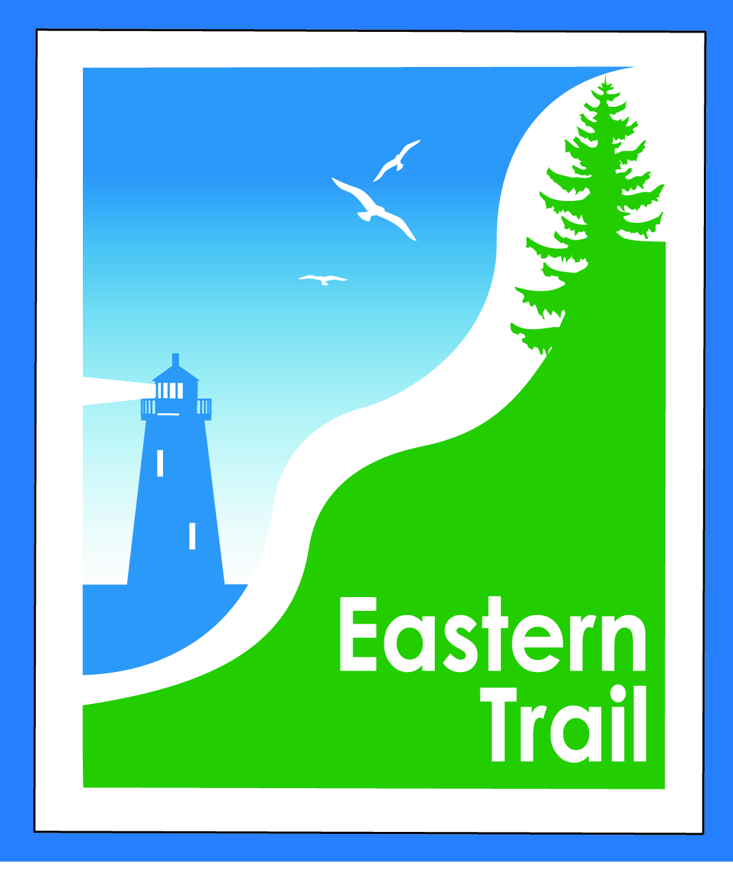

ETMD Board of Directors – Agenda
Kennebunk Town Hall - Third Floor Conference Rm – November 18, 2015 - 8:30 – 10:30 a.m.

- Introductions – 3 min

- Minutes of October 14, 2015 (Bill Reichl will send) – needs vote - 5 min

- Financial Priorities – 20 min
- Review of current financial report – Val/Carole (to follow by Monday) – needs vote
- Initial 2016 request for dues – needs vote - Marianne/Carole
  - Schedule visits to town managers and/or budget committees – Marianne/Carole
- ETMD to hold Public/private funds for trail development – needs vote - Carole/Bill
- Status 990 and RHR audit – Marianne/Carole

- ETMD Priorities - 90 min
  - Management Policies & Procedures
    - Reports from Executive Director and Municipalities (includes status on new projects - Kennebunk, OOB, Scarborough, Wells & Unitil re CLA)
    - Future ET planning – Carole
      - Office space and storage – needs vote
      - Outreach & funding
        - Update on directional trail signage and ETA outreach campaign
    - Trail Maintenance/Repairs/Municipal Reports – Carole

- Other Business - 2 min – issues? Concerns

- Next Meeting – December 9, 2015

- Adjourn

