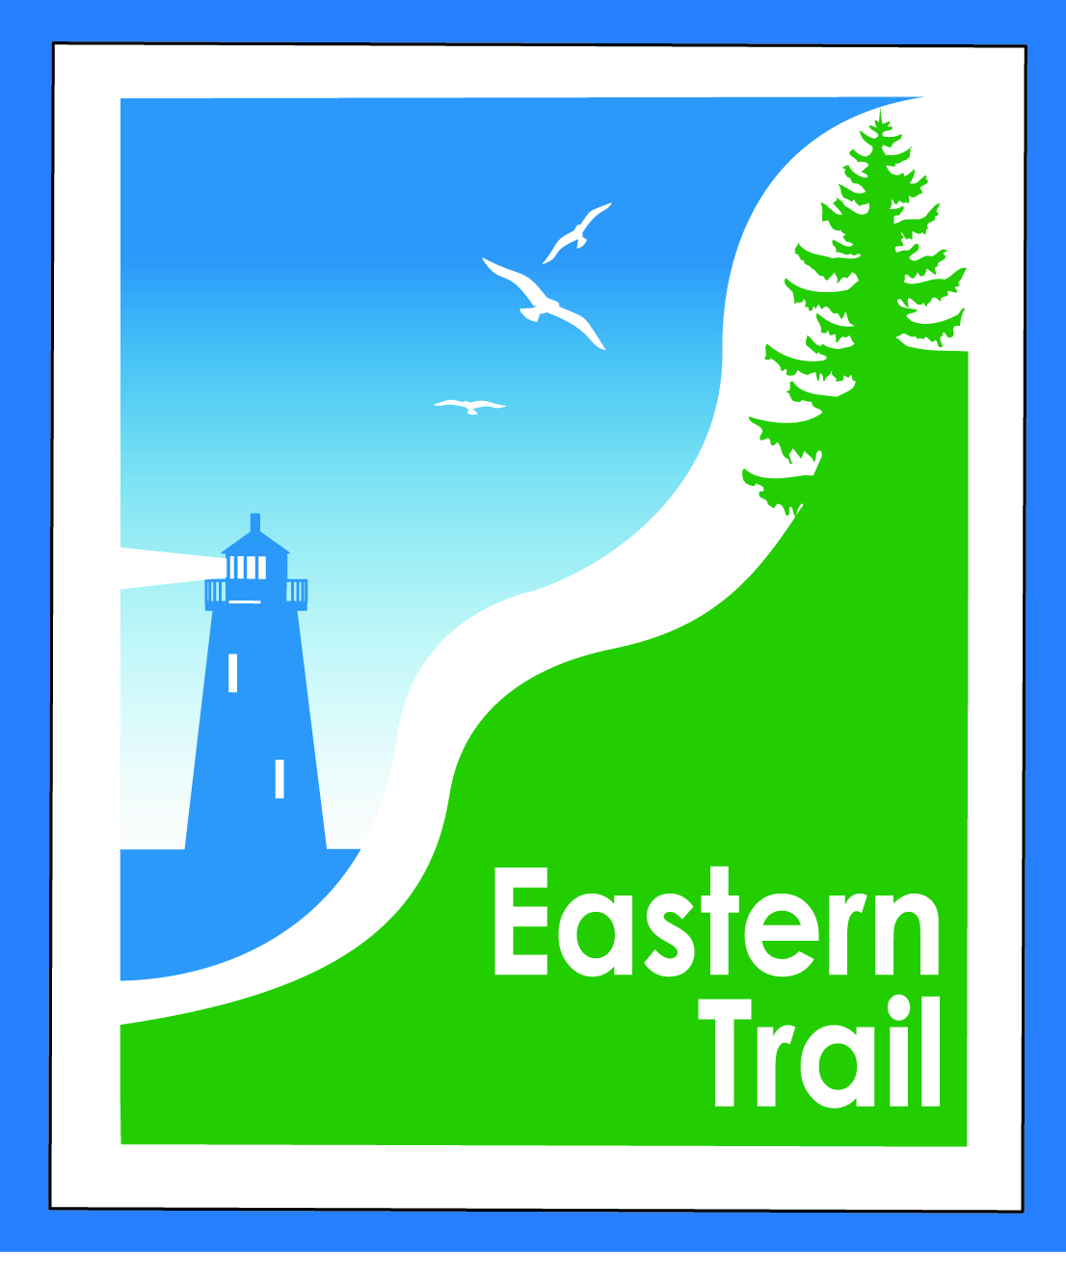

ETMD Board of Directors –Agenda
Kennebunk Town Hall - Third Floor Conference Rm –December 13, 2017 - 8:30 – 10:30 a.m.

- Welcome & Introductions – 2 min
- Minutes of November 8, 2017 (included) needs vote - 5 min

- Financial – 5 min
  - November report (included) - needs vote – Carole, Val
  - Status financial appeal to ETA - Carole
  - Action item – review mid –year budget status, set 2018-2019 ETMD dues fees – Bill, Val
- Operations – 45 min
  - Update Hallczuk legal actions – Tad, Carole
  - Update proposed easements for trail connections – Carole
- Ongoing / Proposed Projects: 45 min
  - Scarborough – 019386.00 Bill, Carole
  - Status Kennebunk – Wells – Marianne, Eric, Carole
  - Reports from Municipalities

- Outreach & Events – 15 min – Carole, Jim
  - EIS - Jim

- Other Business? – 3 min

- Next Meeting – January 10, 2018

- Adjourn

