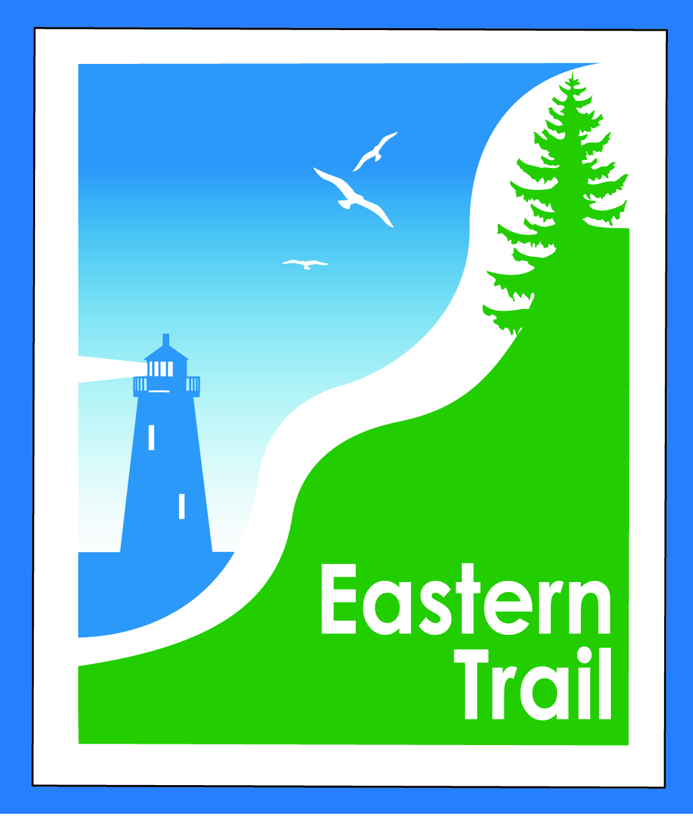

ETMD Board of Directors
Minutes
December 13, 2017
- Officers: Bill Reichl, Scarborough; Eric Labelle, VP; Bob Hamblen, Secretary
- Trustees: Marianne Goodine, Wells; Jim Bucar, ETA; Joe Yuhas, ETA; Tad Redway, Arundel; Eric Labelle, Kennebunk
- Staff: Carole Brush, Executive Director

- Minutes of November 8, 2017 -- motion by Jim, seconded by Tom and so voted, 7-0.

- Financial – 5 min
  - November report (included) - motion by Tad, seconded by Jim, and so voted, 7-0.
  - Status financial appeal to ETA - no additional word, will be addressed on Jan. 24 by ETA. Carole: Ironman Triathlon could be source of revenue, but no reply yet. Fee is $100 per event, plus $10/participant. Also a half marathon in Kennebunk proposed. Eric: motion to accept $5/participant rather than $10 for events over 500 participants, seconded by Bob. They raise money and give to charities, and sustain their own organization. All in favor, 7-0.
  - Action item – review mid –year budget status, set 2018-2019 ETMD dues fees – Bill, Val – Tad proposes to delay until input from ETA. Carole: typically we send out notices Dec. 15, and will not hear anything from ETA until late January. Bill: would fee increase be acceptable to towns? Tad: costs have increased, fees haven’t. Eric: fee increase would be a tough sell. Tad: let’s remember it was the towns that supported this organization. ETMD is an advantage to the towns, otherwise they have to deal with Unitil and other entities. Carole: next year, hope to be able to point to Close the Gap, and to Kennebunk-Wells project. Jim: motion to move forward as is, and to get fee notices out with no increase, seconded by Eric and so voted, 7-0.
- Operations
  - Update Hallczuk legal actions – Tad: Hallczuk didn’t show up at 8:30, instead at 1:00, so it was continued. Carole: is now scheduled for 12/19. The County Deputy will be on vacation, won’t be there. Attorney would like two to testify from Arundel, but Deputy is on vacation, and ACO would be the other. Carole may have to testify for both Arundel case, and ETMD case. Is also last date available before Mr. Dumont (bitten by dog) heads south for winter. Eric: town’s operations manager, Bryan Laverriere, was bitten by Billy’s dog. Carole: a written statement would be helpful.
  - Update proposed easements for trail connections – Carole: yesterday, attorney Tim Murphy Eric: moves to accept the easement as amended, seconded by Jim and so voted, 7-0.
  - Carole: Yes, we are pursuing a trademark for the logo. Tim is working on it.

- Ongoing / Proposed Projects:
  - Scarborough – 019386.00 Bill, Carole: no changes. Will stay within CMP easement, which adds $75,000. Carole: Angela says $4.1 million in costs now. Jim Tasse, John Williams(BCM), Tom Hall and myself will be speaking with MDOT Commissioner next Wed. Day after is next Close the Gap committee meeting. Have requested $25,000 of Quimby. A Kennebunk family has donated $7,500. A Boston-area man has talked about a $30,000 donation, summer place in Prouts Neck. Also, have embarked on a $200,000 grant request to Sewall for bridge over RR tracks, SoPo. Need to demonstrate serving underserved populations. In Biddeford, Saco and Scarborough senior groups use the Trail. Joe: reach out to Southern Maine Agency on Aging. Bob: contact Boy’s and Girl’s Club in SoPo.
  - Status Kennebunk – Wells – Marianne, Eric, Carole: waiting on Letter of Intent from Unitil, promised by Christmas by Roger Barham, Unitil. Meeting of town engineers and managers, Marianne, Carole, a Sebago Technics surveyor. Unitil wants to review in depth, will work with Chris in Kennebunk and Mike of Wells on draft trail alignment. Bad news is its one big wetland, with vernal pools. Would then apply for grants with Unitil support, survey and prelim design. Carole will stay in touch with Roger. MDOT has accepted the survey, and may be reimbursing a portion of costs. Chris Osterrieder suggested that next grant application could include the wetlands and other permits for next 6 mile section, also to extend into rest of Wells section and North Berwick section. Meeting in January perhaps with MDOT, Wells and Kennebunk to discuss. Tad: keeping Pratt and Whitney interested is important. They granted us $5,000. P&W is pursuing a meeting with Hussey Seating, Pike Industries and themselves.
  - Reports from Municipalities: Tad: Arundel has purchased land for a new town hall. A land trust has bought back portion of land, hope to connect parking lot to Eastern Trail. Year-round restrooms! On Limerick Road. Tom: South Berwick, have chatted with Perry Ellsworth. Carole: would like to talk with Council. Tom: SB waiting to see progress thru Wells, North Berwick into South Berwick. There’s interest, to a degree, but how do we get thru North Berwick to get to South Berwick? We have no industry to support the trail.

- Outreach & Events – 15 min – Carole, Jim
  - EIS – Jim: counters are in place on Greenbelt, and surveys distributed. Over 80,000 users counted from Scarborough to Saco in a little over 3 months. Was out by Wainwright, perhaps 25-30 users came by while installing a counter. Surveys are being returned, and preparing a spreadsheet to tally results.

- Other Business? ETA continues full moon walks. Wassailing event raised $100, and well attended. Donations would be welcomed. Night of Jan. 1 Joe will lead his next walk at SMHC, Biddeford.

- Next Meeting – January 10, 2018

- Adjourned at 10:15 a.m.

